**Algorithms in Abracadabra**

Date: 13/10/2020

Author: Wenting Li

|  |  |
| --- | --- |
| Version | Description |
| V1.0 | Initial Version, Describe algorithms in Abracadabra |
|  |  |

**Table of Contents**

1. Algorithms in Abracadabra 2

1.1 Introduction 2

1.2 SFR Test 2

1.2.1 ROI detection 2

1.2.2 SFR calculation 17

1.3 Blemish Test 20

1.3.1 Circular mask generation 21

1.3.2 Dead pixels detection 21

1.3.3 Hot pixels detection 22

1.3.4 Color uniformity test 23

1.3.5 Optical center test 25

1.3.6 Blemish detection 27

1.4 IR leakage Test 31

1.5 IR uniformity 33

1.5.1 Golden sample selector 33

1.5.2 Golden sample matrix generation 34

1.5.3 IRU test 38

1.6 Color Check test 40

1.7 Temporal noise test 40

2. Appendix 41

2.1 How to download source code 41

2.2 How to build the binary files 41

2.3 How to generate AbracadabraGui.exe 41

2.4 How to build the Abracadabra_routine.exe 42

2.5 Abracadabra release process 42

# Algorithms in Abracadabra

## Introduction

Abracadabra is a camera testing software in factory, it supports SFR, Blemish, IR leakage and IR uniformity testing now. More details can be found in the later chapters.

The GUI of Abracadabra:

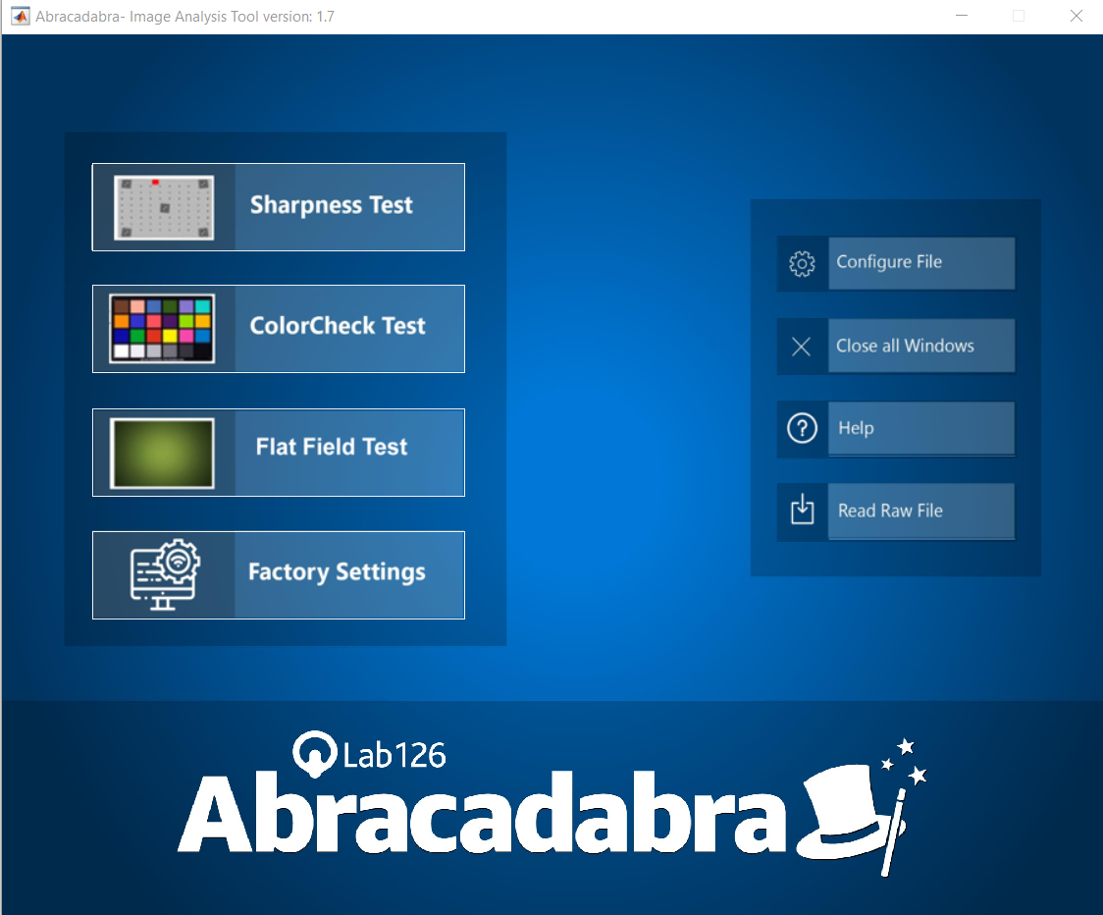

## SFR Test

The brief workflow of SFR (Spatial Frequency Response) test is below. There are two main blocks in SFR test: ROI detection and SFR calculation.



### ROI detection

The brief workflow of ROI detection is below.



#### 1.2.1.1 Lens shading correction

Use the parameter “gray_thr_factor_black” to determine the max LSC (Lens Shading Correction) gain. The LSC factor is calculated by this function:

lsc_image_factor = ((X.^2+Y.^2).^(1/2))./(((image_center_x)^2+(image_center_y)^2)^(1/2)) * (lsc_max_factor - 1)

Calculating the distance ratio between the edge pixels and central pixel, LSC gain is determined by the distance ratio, note that the pixel on the edge will be multiplied max gain, and the center pixel apply 1x gain.

Here is an example of lens shading correction.

|  |  |
| --- | --- |
| Input G channel image | LSC Gain |
|  |  |
| LSC image |  |
|  |  |

#### 1.2.1.2 Camera projection

This module is used to reconstruction world coordinates and re-project world coordinates to pixel coordinates. The detail description is below.

(1) Reconstruction world coordinates

Choose a reference coordinate system in the environment to describe the position of the camera and objects. This coordinate system is called the world coordinate system. When reconstruction world coordinates, we assume image center as origin of world coordinates.

(2) Camera projection model

Here is the projection model, there are three coordinates in the picture: world coordinate, camera coordinate and pixel coordinate.

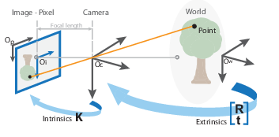

We derive the projection according to this process:



* **Map 3D world coordinates to 3D camera coordinates**

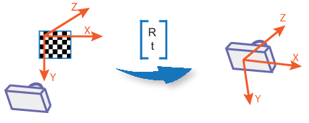

The relationship between the camera coordinate system and the world coordinate system can be described by the rotation matrix R and the translation vector t. Assuming that the coordinates of P in the world coordinate system are (Xw, Yw, Zw), there is the following conversion relationship between the camera coordinate system and the world coordinate system:

$$\left[\begin{aligned}\begin{matrix}x_{c} \\ y_{c}\end{matrix} \\ z_{c} \\ 1\end{aligned}\right]= \left[\begin{matrix}R & t \\ 0 & 1\end{matrix}\right]\left[\begin{aligned}\begin{matrix}x_{w} \\ y_{w} \\ z_{w}\end{matrix} \\ 1\end{aligned}\right]$$

R indicates rotation matrix (3*3) and t indicates translation vector (3*1). The smallest unit of camera coordinate system and world coordinates is mm.

* **Map 3D camera coordinates to 2D image coordinates**

The camera coordinate system is shown in the figure below.

The origin of the camera coordinate system is the optical center, the Xc and Yc axes are parallel to the x axis and the y axis of the imagecoordinate system, and the Zc axis is the optical axis of the camera. The distance from the optical center to the pixel plane is the focal length f

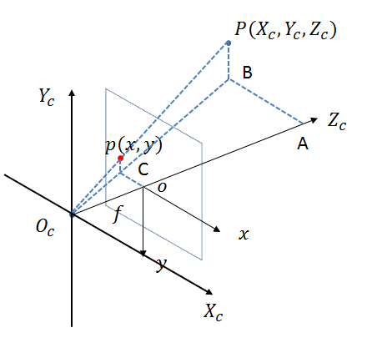

p point is in image coordinates and P is in camera coordinates. The smallest unit of image coordinate is mm.

There is a perspective projection relationship between the points on the camera coordinate system and the points on the imaging plane coordinate system. Assuming that the coordinate of the point P in the camera coordinate system corresponding to p is (Xc, Yc, Zc), there is the following conversion relationship between the imaging plane coordinate system and the camera coordinate system.

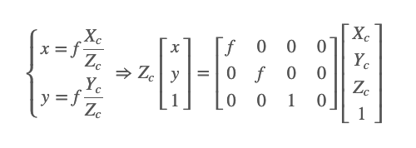

* **Map image coordinates to pixel coordinates** (Conversion from mm to pixels)

At this step, map 2D image to 2D pixel:

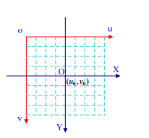

Optical center: ($u_{0}, v_{0}$)

The relationship between image coordinates and pixel coordinates is as follow:

(u – $u_{0}$) = $X$/ $d_{x}$

$d_{x}$ represents size of pixel width

(v – $v_{0}$) = Y/ $d_{y}$

$d_{y}$ represents size of pixel height

* **Convert 3D world coordinates to 2D pixel coordinates**

The conversion between the world coordinate system and the pixel coordinate system can be realized through the above four coordinate systems, as shown below:

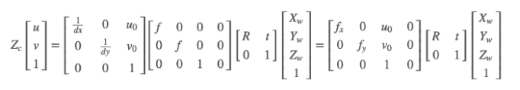

#### 1.2.1.3 Corner detection

The module is use to detect checker patterns in the test chart, a brief workflow is below:

Firstly, binary the image with white threshold; Secondly, detecting the connect areas in the binary image; Third, using thresholds to filter connected areas; Fourth, calculating the centroids of the connected areas.

Here is an example of detected centroids.

|  |
| --- |
| Detected centroid |
|  |



#### 1.2.1.4 Diamond detection

The detail procedure is below:



1. **Use the five corners detected in the previous chapter to decide the binary threshold**

Use the parameter ‘contrast threshold’ to adjust threshold, the function used is below:

location_thr = graythresh (rectangle_im)/contrast threshold

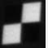

1. **Average the five thresholds, then use the threshold to binary image.**
2. **Detect all the connection areas in the binary image**
3. **Use the diamond area to filter these connection areas.**

If the size of connection area is between low threshold and high threshold, it will be detected as a diamond. The diamond Edge is defined in chart geometry and will be re-projection before used. Detailed description is in chapter 1.2.1.2. Diamond area is equal to the square of the edge.

The threshold used is defined as below:

Low threshold = diamond area * 0.4

High threshold = diamond area * 1.6

1. **Set threshold to qualify points**

* Compute the Euclidean distance between ideal re-projection points and the diamond centers.
* Find the medium value among these distance matrix （68*1）
* Threshold is set as 8 times medium value and clip between 50 and 200
* If the Euclidean distance is larger than the threshold, this diamond will be excluded.

1. **Check the centroids is not close to checkerboard pattern centroids**

* Compute the Euclidean distance between the checker and diamond centroids
* Set the distance threshold as $0.02* \sqrt{w^{2}+h^{2}}$
* If the Euclidean distance is smaller than the distance threshold, this diamond will be excluded.

1. **Sort diamonds points**

For example, the diamond number in each row is [6 10 10 8 8 10 10 6]

We sort diamonds row by row

1. For the first row

* Sort the diamonds coordinates in vertical detection
* Find the 6 diamonds in first row
* Sort the 6 diamonds and find the first diamond in first row and set it as the target diamond
* search the diamond which is closest to the target diamond

Because all the other diamonds are in the right side of the first diamond in first and last row

The Valid point need to meet two requirements:

(1) The horizontal coordinate should be larger than the target diamond

(2) The vertical coordinate different between valid point and target diamond should be smaller than 50

Find the closest one in all the valid points and set the closest one as the new target diamond

If the valid point equal 0, print error message “No points are present to the right side here”

But note that when search for the 4th diamond, the new target diamond is reset to first diamond.

1. For all the other rows

* Calculate the Euclidean distance between previous anchor point and other points
* Find the closest one as the target point
* search the diamond which is closest to the target diamond

Because two points are in the left side, when search left valid points, the two requirements is change to

(1) The horizontal coordinate should be smaller than the target diamond

(2) The vertical coordinate different between valid point and target diamond should be smaller than 50

When searching for the right side valid points, it’s the same as the first row.

Here is an example of detection process.

|  |  |
| --- | --- |
| Gray image | Binary image |
|  |  |
| Reversed binary image | Detected diamonds |
|  |  |
|  | An example of invalid connection area |
|  |  |

#### 1.2.1.5 Estimate camera pose

At this step, estimating the rotation matrix R (3*3) and translation vector t (3*1). And then derive roll, Yaw, Pitch from the rotation matrix.

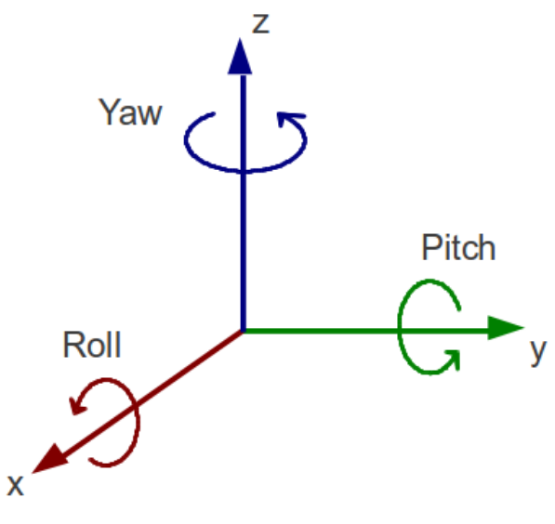

A yaw is a counterclockwise rotation of α about the z-axis. The rotation matrix is given by

$$R_{z}\left(α\right)= \left(\begin{matrix}\cos{α} & -\sin{α} & 0 \\ \sin{α} & \cos{α} & 0 \\ 0 & 0 & 1\end{matrix}\right)$$

A pitch is a counterclockwise rotation of β about the y-axis. The rotation matrix is given by

$$R_{y}\left(β\right)= \left(\begin{matrix}\cos{β} & 0 & \sin{β} \\ 0 & 1 & 0 \\ -sin{β} & 0 & \cos{β}\end{matrix}\right)$$

A roll is a counterclockwise rotation of γ about x-axis. The rotation matrix is given by

$$R_{x}\left(γ\right)= \left(\begin{matrix}1 & 0 & 0 \\ 0 & \cos{γ} & -\sin{γ} \\ 0 & \sin{γ} & \cos{γ}\end{matrix}\right)$$

Here is a description in 3-D and 2- D.

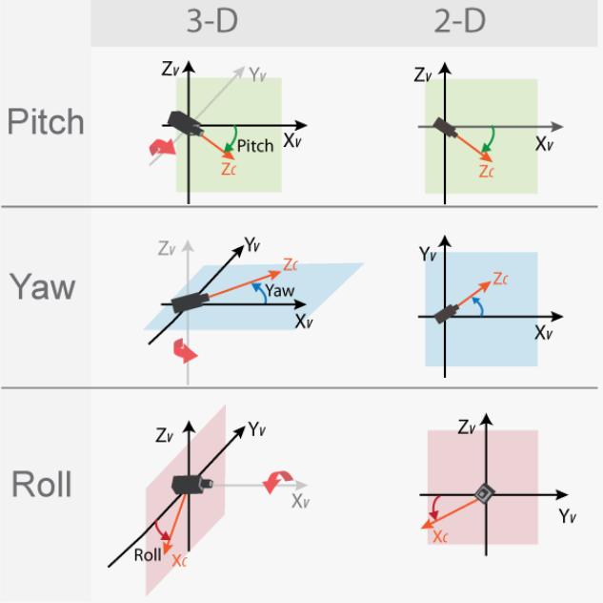

The rotation matrix is writing as:

$$R= \left[\begin{matrix}R_{11} & R_{12} & R_{13} \\ R_{21} & R_{22} & R_{23} \\ R_{31} & R_{32} & R_{33}\end{matrix}\right]$$

A single rotation matrix can be formed by multiplying the Yaw (α), pitch (β), roll (γ) rotation matrix to obtain:

$$R\left(α,β,γ\right)= R_{z}\left(α\right)R_{y}\left(β\right)R_{x}\left(γ\right)=$$

$$\left(\begin{matrix}\cos{α}\cos{β} & \cos{α\sin{β\sin{γ- \sin{α}\cos{γ} }}} & \cos{α\sin{β\cos{γ}{+ \sin{α}\sin{γ} }}} \\ \sin{α}\cos{β} & \sin{α}{\sin{β\sin{γ+ \cos{α}\cos{γ} }}} & \sin{α}\sin{β}\cos{γ}- \cos{α}\sin{γ} \\ -\sin{β} & \cos{β}\sin{γ} & \cos{β}\cos{γ}\end{matrix}\right)$$

By setting each entry equal to its corresponding entry, the yaw, pitch, roll could be calculated with these expressions:

$$α= \tan^{-1}{(\frac{R_{21}}{R_{11}})}$$

$$β= \tan^{-1}{(\frac{-R_{31}}{\sqrt{{R_{32}}^{2}+{R_{33}}^{2}}})}$$

$$γ= \tan^{-1}{(\frac{R_{32}}{R_{33}})}$$

#### 1.2.1.6 Compute FOV

At this step, calculating the HFOV (horizontal field of view), DFOV (Diagonal field of view), VFOV (vertical field of view), and Here is a brief description of typical FOV calculation.

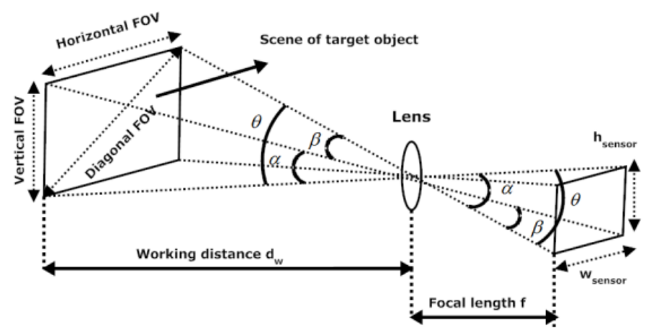

From this picture, we can see that the HFOV, DFOV, VFOV can calculated by using these expressions

$$HFOV=2\tan^{-1}{(\frac{pxs ×w}{2f})}$$

$$VFOV=2\tan^{-1}{(\frac{pxs ×h}{2f})}$$

$$DFOV=2\tan^{-1}{(\frac{\sqrt{{(pxs×w )}^{2}+{(pxs×h )}^{2}}}{2f})}$$

$pxs$ Means the pixel size (um), $w$ means the width of the image sensor (mm), h means the height of the image sensor (mm), and f is the focal length (mm).

Abracadabra tools use checker pattern centroids and diamonds to calculate FOV, the detail work flow is below.

1. If there is no distortion, use checker pattern centroids to compute distance.
2. If there is distortion, use checker pattern centroids to compute Diagonal distance. Use diamonds to compute horizontal and vertical distance. For vertical FOV calculation, find the top most and bottom most diamond, calculate the vertical distance between these two diamonds. Please note that if the x coordinates difference of these two diamonds is larger than 100, tool will display error message.

For horizontal FOV calculation, find the left most and right most diamond, calculate the horizontal distance between these two diamonds. Please note that if the y coordinates difference of these two diamonds is larger than 100, tool will display error message.

For diagonal FOV calculation, use the top Left Square and bottom Right Square, compute the two square’s distance in pixel and mm. please note that, use the left most edge centroid and the right most edge centroid to calculate x distance in pixels, use the top most edge centroid and the bottom most edge centroid to calculate y distance in pixels.

1. Use this function to compute FOV:



$$HFOV=2\tan^{-1}{(\frac{pxs ×object width}{2×working distance})}$$

$$VFOV=2\tan^{-1}{(\frac{pxs ×object height}{2×working distance})}$$

$$DFOV=2\tan^{-1}{(\frac{pxs ×object diagonal}{2×working distance})}$$

#### 1.2.1.7 Compute bar2bar distance

The brief workflow is below:



At this step, we estimate the bar2bar distance by detecting the centroid points of the upper and lower bar.

* Firstly, obtain the upper and lower bar world coordinate
* Secondly, re-project the world coordinate to pixel coordinate, detail description is in chapter 1.2.1.2 ‘camera projection’
* Third, obtain the edge ROI and compute the average of each column.
* Forth, applying filter to detect the bar, the filter coefficient is [1,1,1,-6,1,1,1], filter shape is below:

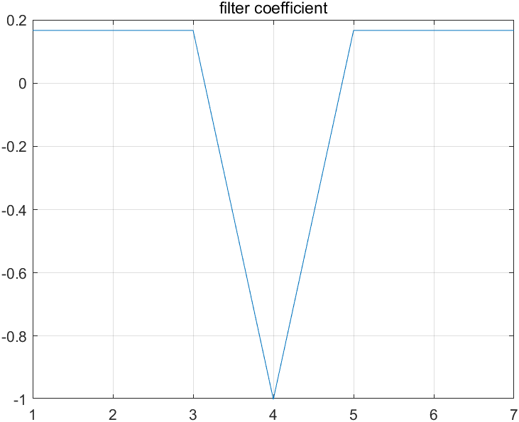

* Fifth, find the centroid y position in the filtered image
* Sixth, average the left x and right x coordinate as the bar x position
* Seventh, subtract the bar upper and lower y coordinate as the bar distance.

Here is an example of detection process.

|  |  |
| --- | --- |
| Flipped bottom ROI | Averaged ROI |
|  |  |
| Detected edge | Peak value (centroid = 9.45 in ROI) |
|  |  |
| Detected bar to bar distance | |
|  | |

### SFR calculation

This block is used to calculate SFR (Spatial Frequency Response) from a slanted-edge. The brief workflow is below.



Firstly, detecting the edge of the ROI; secondly, calculating the ESF (Edge Spread Function); thirdly, calculating the LSF (Line Spread Function). At last, applying FFT (Fourier transform) to the LSF to obtain SFR.

1. **Check the contrast of the ROI**

Calculate the normalized difference between left-side 5 columns’ sum and right-side 5 columns’ sum, check if the difference is lower than 0.1.

1. **Calculating the derivative of ROI**

Using filter [0.5,-0.5] to calculate the ROI derivative, here is an example.

|  |  |
| --- | --- |
| Detected ROI | derivative of ROI |
|  |  |

1. **Calculating centroids for derivative array**

Apply a hamming window to smooth the derivative array and Find the centroid for each line. The typical hamming window used is below. Applying the Hamming window before calculating the centroids makes edge detection much more stable.

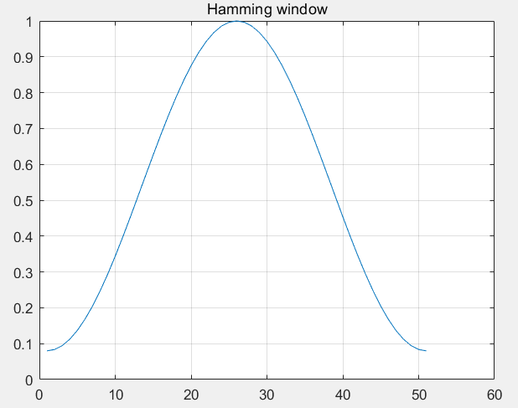

Apply hamming window to each line (51*1)

For example, the first scan line after applying hamming window.



1. **Fit a linear equation to the centroid location**
2. **Binning and calculating the ESF of ROI**

At this step, project the date along edge direction, then accumulated and averaged the data which has the same distance to the edge, here is an example of ESF.

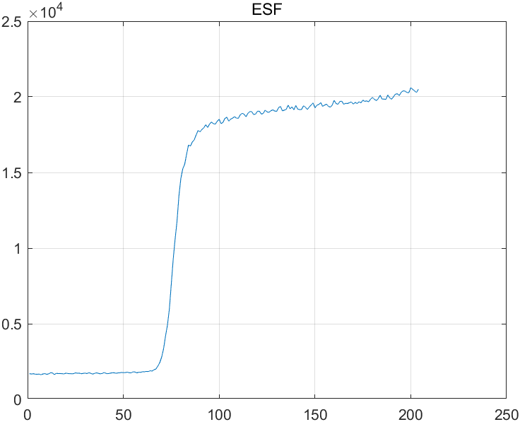

1. **Calculating the LSF of ROI**

The LSF is the first derivative of ESF and sfrmat3 use [-0.5 0 0.5] to filter the ESF

Here is an example of LSF

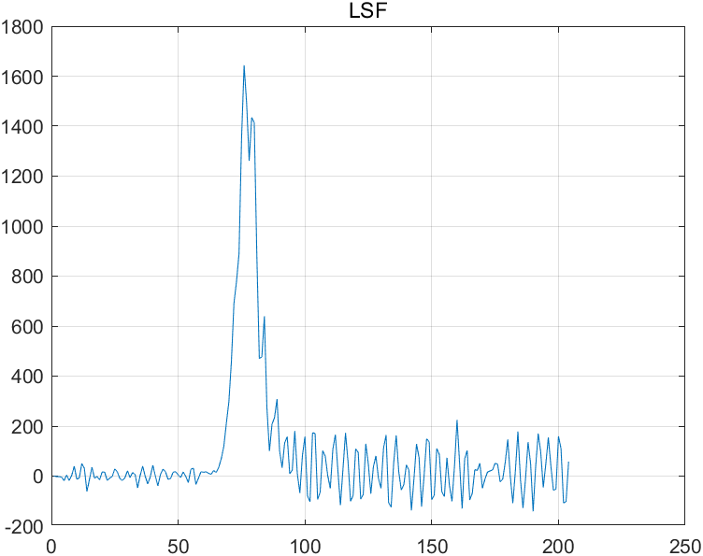

1. **Applying Hamming window to the LSF**

Apply hamming window to smooth LSF

1. **Calculating the Spatial Frequency Response (SFR)**

The SFR is an absolute value of the Fourier transform of the LSF.

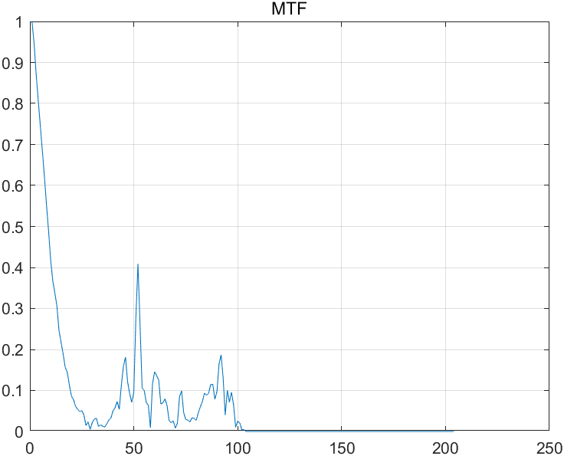

Here is an example of the result displayed in Abracadabra.

All the ROIs detected:

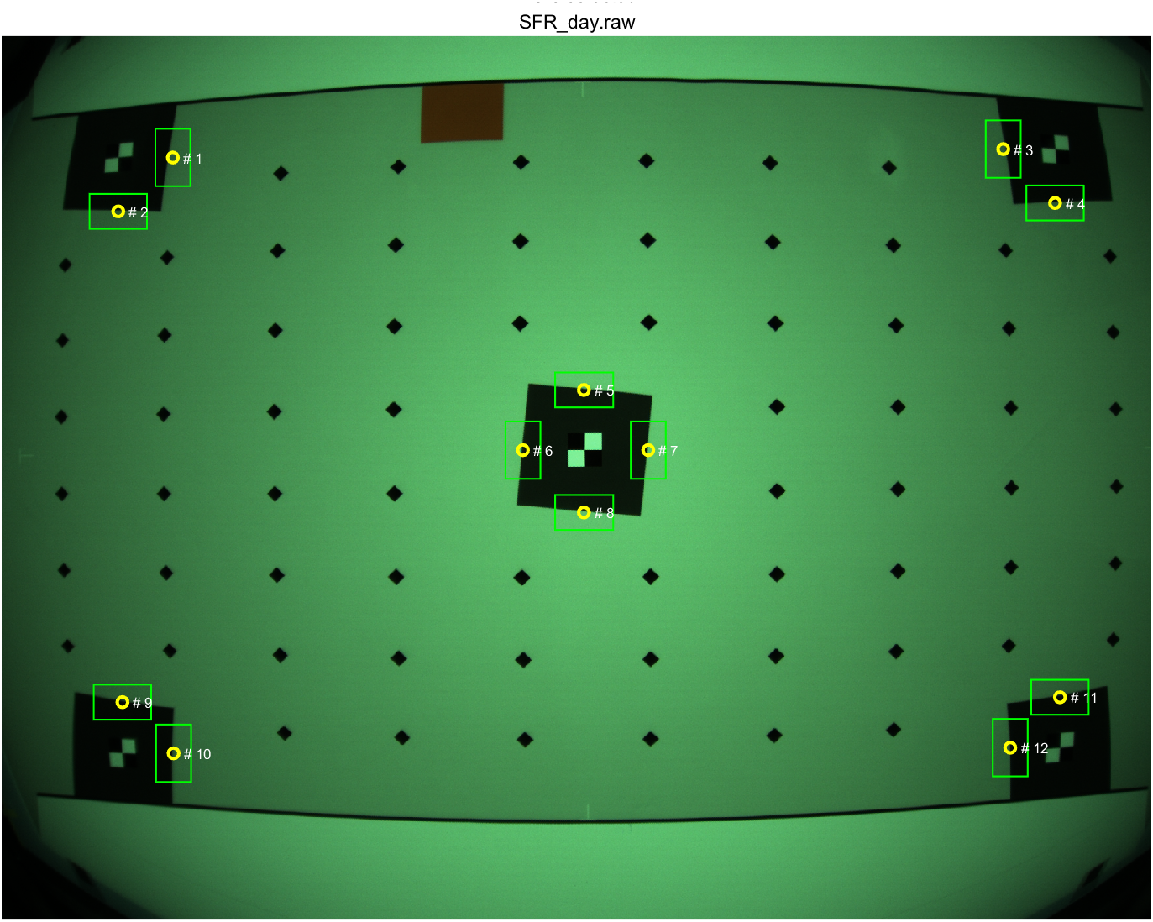

The MTF response for ROI #1

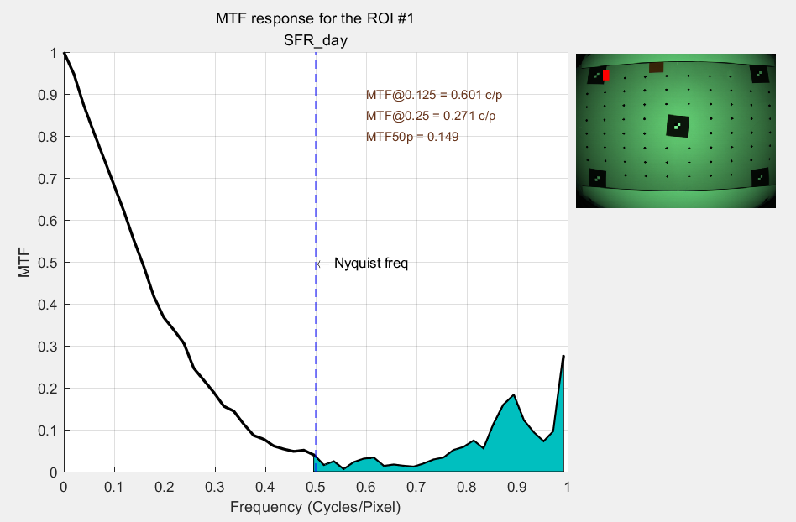

Please note that in the pass or fail section, SFR in the center use the mean value of central ROIs and SFR in the corner use the minimum value of corner ROIs.

## Blemish Test

In this test module, there are several function inside, here is the brief work flow



### Circular mask generation

This module is used to generate circular ROI mask, this mask is used in blemish detection and dead pixels detection. The brief work flow is below.



Here are examples with different settings.

|  |  |
| --- | --- |
| Radius scale = 0.8 | Radius scale = 1 |
|  |  |

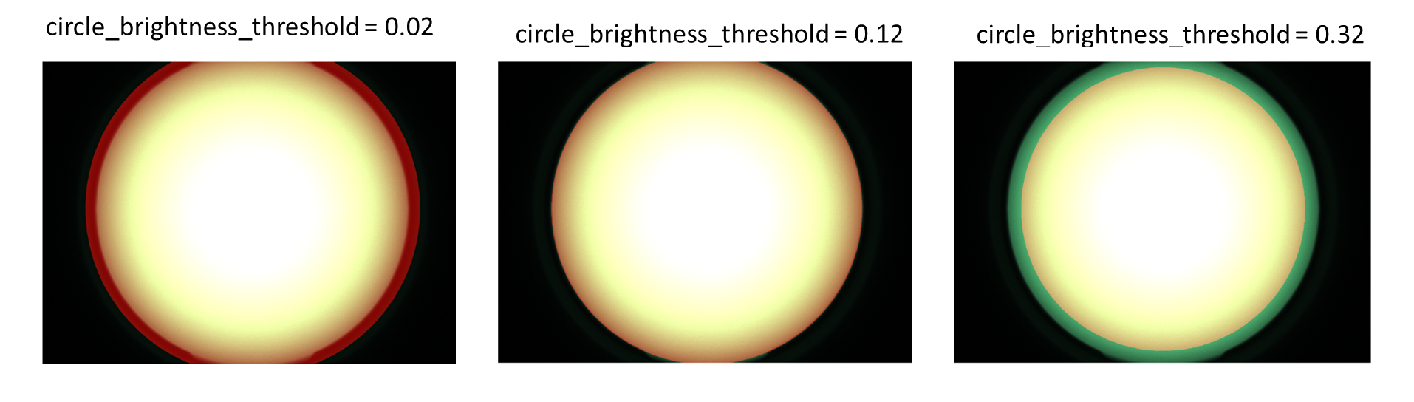

The red areas indicate the mask detected by abracadabra, the green areas indicate the original raw image.

The smaller the threshold, the more the circle extend to the dark area. Please note that the extreme small threshold may cause the detection inaccurate.

### Dead pixels detection

This block is used to detect dead pixels in light field. The main idea is calculate the difference between central pixel and the average of surrounding pixels, if the difference is above the threshold, the central pixel will be detected as dead pixel.



### Hot pixels detection

This block is used to detect hot pixels in dark field, if the pixel value is larger than the absolute hot threshold, it will be detected as hot pixel. The brief work flow is below.



### Color uniformity test

This block is used to calculate color uniformity, this module checks how consistent and uniform the grey color is across the image, test conditions reference to the test plan. This module calculate R/G and B/G ratio from the corner to center. And the module also calculate the mean illuminance ratio between corner ROIs and central ROI.

The brief work flow is below.



Here is an example of test result:

|  |
| --- |
| Test results |
|  |

### Optical center test

This module is used to calculate the optical center, the main idea of this module is to find the top 95% brightest pixel’s position in the rectangle area. The optical center is related to the illuminance distribution in the rectangle area. The brief work flow is below.



There are three steps:

(1) Define the areas to calculate optical center

The default setting in horizontal is from 0.25*width to 0.75*width, vertical is from 0.25*height to 0.75 height, and then check if the ROI width is smaller than the region threshold. If it’s smaller, then re-calculate the center area.

Here is an example, the ROI is in the green rectangle.

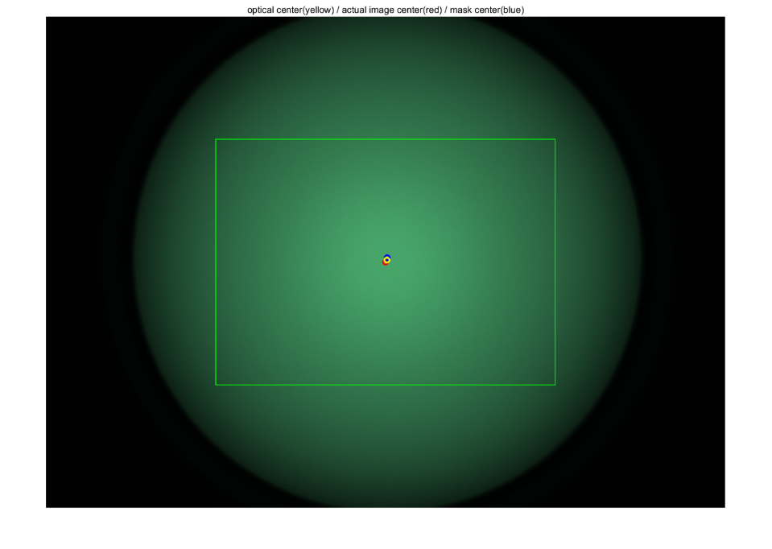

(2) Calculate the horizontal and vertical optical center

The detail work flow in horizontal direction is below, the same operation in vertical detection.

Find pixels above 95% peak and average these pixels position.



For example, the distribution of the pixel above top 95% peak.



### Blemish detection

The purpose of this block is to detect the large-area low-contrast defects in the image, test conditions reference to the test plan. The blemish detection has two stage:

**Stage 1**: detect blemish in down sample image (for example, the resolution is 2688*1944, the downsize scale is 0.5, the down sample image is 1344*972)

**Stage 2**: Down sample image again and detect in lower resolution image. (For example, the downsize scale2 is 0.25, the down sample image is 336*243)

In each stage use two Gaussian filters, one is used to filter low frequency and the other is used to filter high frequency. If there is no blemish, the difference between low and high frequency should be small and smooth and no obvious edge. Then we use canny method to detect edge in difference, if there is an edge means potential blemish exist. The detail work flow is below.

Here is an example of blemish detection.

|  |
| --- |
| Raw image |
|  |
| Blemish detected |
|  |

|  |  |
| --- | --- |
| Gaussian difference 1 | Gaussian difference 2 |
|  |  |
| Potential blemishes from difference 1 | Potential blemishes from difference 2 |
|  |  |



## IR leakage Test

This block is used to test IR leakage, test conditions reference to the test plan.

The brief work flow of this module is below



This module calculate average value in each block and R/B and B/G ratio in the defined central block. In test condition, if there is no IR leakage, the average in each block should close to zero (after subtract sensor black level).

The detail work flow in Block test is below for your reference.

Here is an example of test results, label all the average in each blocks.

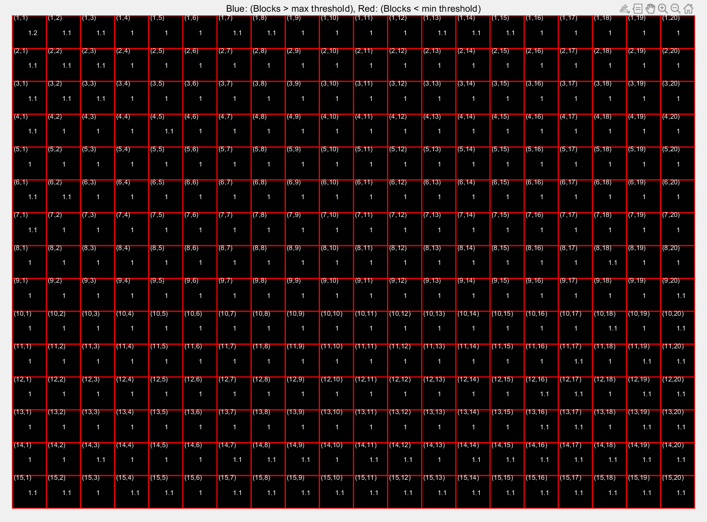



Notes:

When selected the ROIS, the 1st number means the block y index, the 2nd number means the block x index, this example selected two blocks, and the parameter expected_roi_values and deviation_allowed_pct should have the same size with selected block numbers.



## IR uniformity

### Golden sample selector

Here is the jellyfish for reference, Jellyfish has three LEDs front-facing, 150(L) + 90 + 150 (R)

(1) Design several lots base on LED specification

Separate LED into different group base on their minimum and maximum power

Dual 150 degree IR LEDs use A1-A2 bins, single 90 degree IR LED use F1-F2 bins.

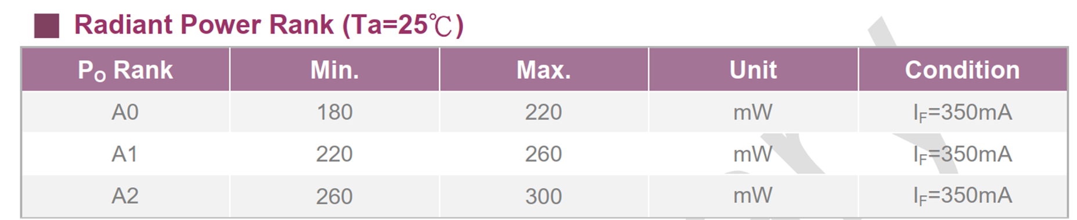

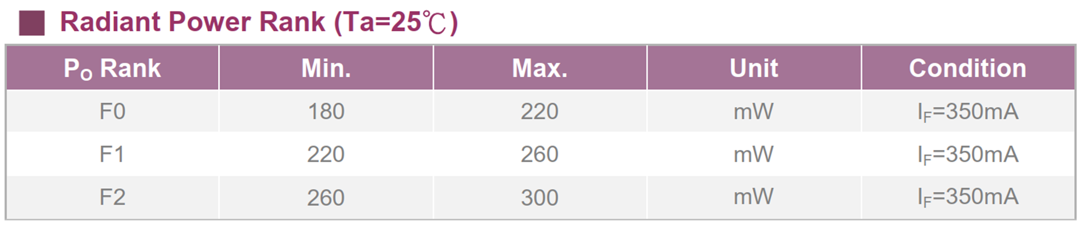

The design bin matrix is below

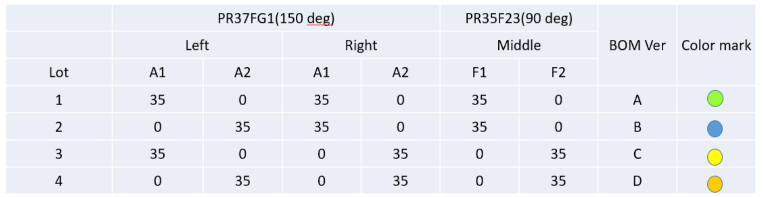

(2) IQ engineer choose Lot 1 and 4 for test (Lot 4 has the strongest power) .They build 35 devices for each Lot

* In EVT build, use few devices to generate initialize GS matrix
* Use Abracadabra tools to test the 35 devices and get the total flux percentage results (the mean ratio between LPF image and GS)
* Sort the 35 test results, pick the top 10 total flux percentage device.

(The process means they pick devices with top 10 average values)

(3) Capture raw data to generate golden sample matrix. In the next chapter, they mix the configuration 1 and 4 raw data which has same degree.

|  |  |  |  |
| --- | --- | --- | --- |
| Configuration 1 | | Configuration 4 | |
| 90 degree | 150 degree | 90 degree | 150 degree |
| 10 raw data | 10 raw | 10 raw | 10 raw |

### Golden sample matrix generation



#### 1.5.2.1 Procedure

1. **Apply medium filter and Gaussian filter to the test images**

Relative parameter: Prefilter sigma, Median filter size

1. **Image mask generation**
2. Calculate the mean average of the ten input images
3. Binary the average image by Mask Brightness Threshold
4. Find the max connection area as the mask
5. Erode mask by disk-shaped structure with the radius 2*ceil(Mask Smoothing Sigma * Mask Edge Masking) + 1
6. Use Gaussian filter smooth the eroded mask, kennel size defined by Mask Smoothing Sigma

|  |  |
| --- | --- |
| **Original mask** | **Erode mask** |
|  |  |
| **Filtered mask (final mask)** |  |
|  |  |

1. **Trim test images**

The purpose of this function is to find the images whose mean value within valid range.

**Firstly**, calculate the mean of each test image;

**Secondly**, find the medium value ‘med_flux’ in the means of test images;

**Third**, find valid images whose mean value between med flux* flux_valid_range (2) and med_flux* flux_valid_range (1)

**Forth**, recalculate mean value of those valid images;

**Fifth**, calculate the normalized standard deviation of those valid images;

**Sixth**, output the valid image and normalized standard deviation.

1. **Calculate the golden sample coefficients of valid images**

Filtering images use DTC to obtain images with low resolution (golden sample resolution)

(For example: input 10 images with original resolution: 2592*1944, output 10 golden sample with resolution: 92*74)

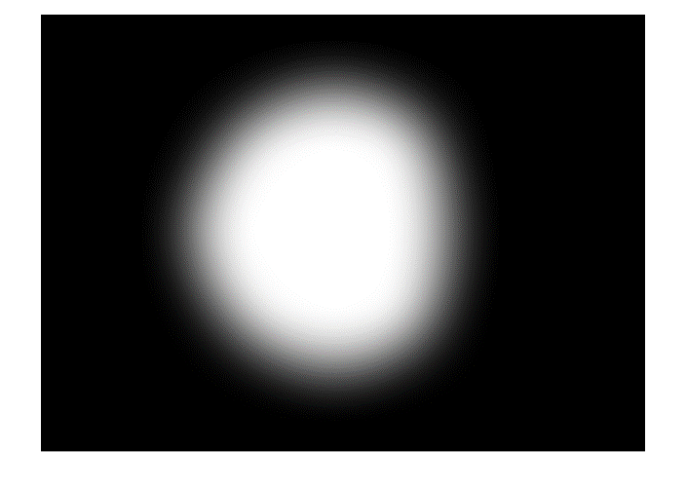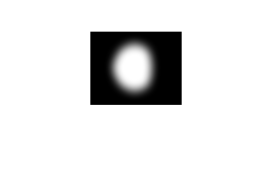

1. **Calculate the numbers to keep**

Relative parameter: FittingResidualFractionToKeep

1. **Select candidates set by fitting residual**

If candidates number is larger than numbers to keep, trim candidates which has the residual compare to medium residual, trim candidate one by one.

* Apply DCT to the original image to obtain LPF image which has same resolution with GS (golden sample).
* Calculate the mean ratio between LPF (low pass filter) image and GS image.

dc_ratio = mean (LPF image)/mean (GS Image)

* Align LPF image to GS Image with dc_ratio.
* Calculate the difference between the aligned LPF image and GS image.

The function is gs_match = (img_lpf/dc_ratio – gs_image)*mask

Please note that if img_flt and img_ft are the same, which means no test image was trimmed, the dc_ratio is 1 and gs_match is 0.

* Up-sample the LPF image to full resolution
* Calculate the fitting Residual

Calculate the L1 and L2 difference between original image and up-sample LPF image.

Residual = original image - up-sample LPF image

|  |  |
| --- | --- |
| l1_match | max(abs(gs_match) / NormY |
| l2_match | STD(gs_match) / NormY |
| l1_residual | max(abs(fit_res)) / NormY |
| l2_residual | STD (fit_res) /NormY |

|  |  |
| --- | --- |
| Golden sample mismatch | Residual |
|  |  |

* Trim test image which has the maximum residual compare to medium residual

(For example, after this process, we select 5 out of 10 candidates)

1. **Select candidates set by difference metric**

The procedure is similar to step (6), the difference is that we calculate L1 and L2 GS match between current images with other images. Trim the test image which has the maximum L1 and L2 GS match.

(For example, after this process, we select 3 out of 5 candidates)

1. **Combine coefficients**

Average coefficients of 3 candidates

1. **Save results**

|  |  |
| --- | --- |
| Golden sample image | mask |
|  |  |

#### 1.5.2.2 GUI

1. Run “extractorApp.m”
2. Fill in the parameters and input folder directory and click “Run”, tool will generate the *.mat

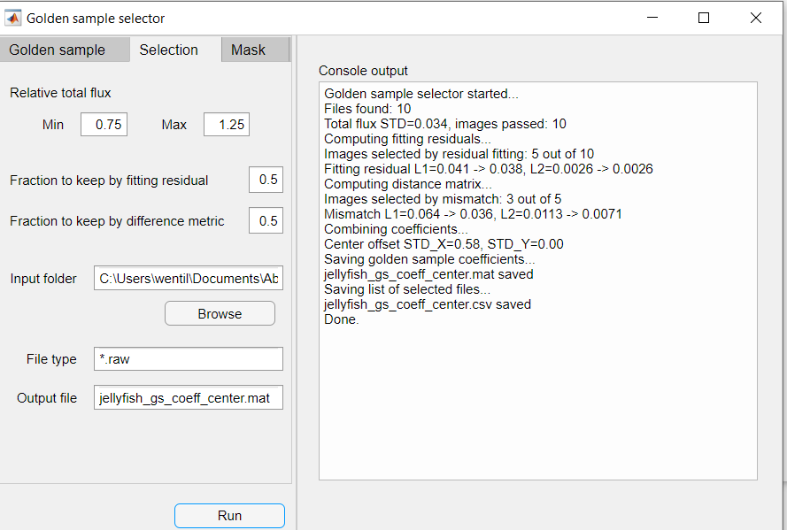

### IRU test

The brief work flow of this module is below



The detail work flow in the IRU test



In the ‘compute results’ module, the procedure is similar with chapter 1.5.2

* Apply DCT to the original test image to obtain LPF image which has same resolution with GS (golden sample).
* Calculate the mean ratio between LPF (low pass filter) image and GS image.

dc_ratio = mean (LPF image)/mean (GS Image)

* Align LPF image to GS Image with dc_ratio.
* Calculate the difference between the aligned LPF image and GS image.

The function is gs_match = (img_lpf/dc_ratio – gs_image)*mask

Please note that if img_flt and img_ft are the same, which means no test image was trimmed, the dc_ratio is 1 and gs_match is 0.

* Up-sample the LPF image to full resolution
* Calculate the fitting Residual

Calculate the L1 and L2 difference between original image and up-sample LPF image.

Residual = original image - up-sample LPF image

A test results is below:

The smaller GS match value means the device is more close to the GS.

|  |  |
| --- | --- |
| Original image | IRU mismatch |
|  |  |
| IRU residual |  |
|  |  |

## Color Check test

TBD

## Temporal noise test

TBD

# Appendix

## How to download source code

**Firstly**, get gerrit6 access, you can follow the instructions here:

<https://openweb.labcollab.net/gerrit6.html>

**Secondly**, update GIT configuration, you can follow the instructions here:

<https://openweb.labcollab.net/gitconfig/>

**Third**, check if you can access to this page

<https://gerrit6.labcollab.net/gerrit/#/c/769381/>

Then you can use the command to clone the abracadabra project:

git clone ssh://wentil@gerrit6.labcollab.net:9418/abracadabra

By the way, you can view all the changes in this page

<https://gerrit6.labcollab.net/gerrit/#/q/abracadabra>

Or use ‘git log --stat’ to track all the changes in the project

## How to build the binary files

1. Download the JsonLab library ‘**jsonlab-1.9.8**’ and put it into the source code folder
2. Add this command ‘**addpath('./jsonlab-1.9.8');**’ into the file ‘ addpath_abracadabra.m’
3. Add all the modules into Matlab path by running ‘addpath_abracadabra.m’
4. Run ‘buildmodule.m’ and the results will be saved in Builder/bin/module folder

Each folder contains these files below.

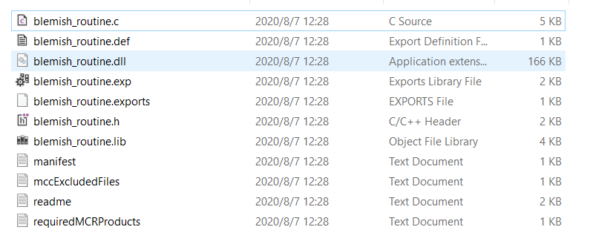

## How to generate AbracadabraGui.exe

1. Enter ‘deploytool’ in Matlab command window
2. Choose the ‘Application compiler’

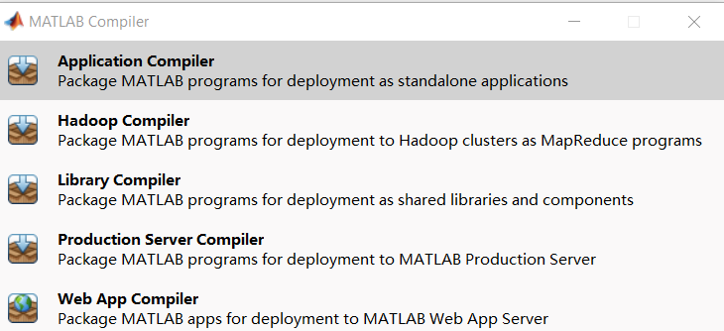

1. Add file to the compiler, and click the ‘Package’ button

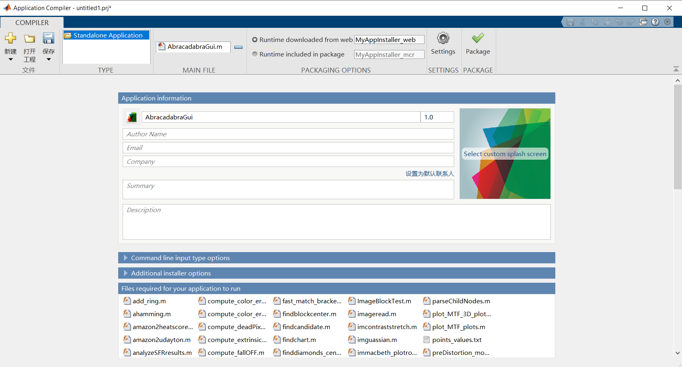

Set a folder to save the results, you will find this four files in the folder

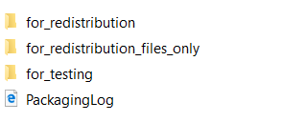

## How to build the Abracadabra_routine.exe

1. Use the C++ project in this folder “Abracadabra_c_library\Abracadabra_routine” to build Abracadabra_routine.exe. Before building, you need to put the *.lib/*.dll/*.h files in the ‘lib’ folder for each module.
2. Setting the project properties

In the C/C++ page, add ‘C:\Program Files\MATLAB\MATLAB Runtime\v98\extern\lib\win64’ and ‘C:\Program Files\MATLAB\MATLAB Runtime\v98\extern\include’ to Additional include directories. In the Linker/input page, add additional Dependencies. In the Linker/General page, add Additional Library Directories.

1. Then build the project, the release file will be save in this folder ‘Abracadabra_c_library\Abracadabra_routine\x64\Release’

## Abracadabra release process

**Firstly**, download the source code from gerrit6 and confirm use the right version.

**Secondly**, modify the configuration file according to the test plan given by architecture engineer.

**Third**, compile the code into production line tools.

**Forth**, Use the data from previous projects to verify the tools.

**Fifth**, if the verification runs well, you could the tools to factory. If there is any issues in the factory, you need to collect data, analyze data and go back to the step #2.

There are four common Issues will encountered in the process

* Chart design issue
* Configuration file issue
* Test SW issue
* Abracadabra SW issue